**NAME-MASHEERA AFRIN**

**SUPERSET ID:6362071**

1. **REACTJS-HANDSON**

**App.js**

import React, { useState } from 'react';

import ListofPlayers from './components/ListofPlayers';

import Scorebelow70 from './components/Scorebelow70';

import OddPlayers from './components/OddPlayers';

import EvenPlayers from './components/EvenPlayers';

import ListofIndianPlayers from './components/ListofIndianPlayers';

export default function App() {

const [flag, setFlag] = useState(true);

const toggleFlag = () => setFlag(!flag);

const players = [

{ name: 'Jack', score: 50 },

{ name: 'Michael', score: 70 },

{ name: 'John', score: 40 },

{ name: 'Ann', score: 61 },

{ name: 'Elisabeth', score: 61 },

{ name: 'Sachin', score: 95 },

{ name: 'Dhoni', score: 100 },

{ name: 'Virat', score: 84 },

{ name: 'Jadeja', score: 64 },

{ name: 'Raina', score: 75 },

{ name: 'Rohit', score: 80 },

];

const IndianTeam = ['Sachin1', 'Dhoni2', 'Virat3', 'Rohit4', 'Yuvaraj5', 'Raina6'];

const T20Players = ['First Player', 'Second Player', 'Third Player'];

const RanjiTrophyPlayers = ['Fourth Player', 'Fifth Player', 'Sixth Player'];

const IndianPlayers = [...T20Players, ...RanjiTrophyPlayers];

return (

<div style={{ padding: '20px' }}>

<button onClick={toggleFlag} style={{ marginBottom: '20px' }}>

Toggle View (Flag is {flag.toString()})

</button>

{flag ? (

<div>

<h1>List of Players</h1>

<ListofPlayers players={players} />

<hr />

<h1>List of Players having Scores Less than 70</h1>

<Scorebelow70 players={players} />

</div>

) : (

<div>

<h1>Indian Team</h1>

<h2>Odd Players</h2>

<OddPlayers players={IndianTeam} />

<hr />

<h2>Even Players</h2>

<EvenPlayers players={IndianTeam} />

<hr />

<h2>List of Indian Players Merged:</h2>

<ListofIndianPlayers IndianPlayers={IndianPlayers} />

</div>

)}

</div>

)**;**

}

**EvenPlayer.js**

import React from 'react';

export default function EvenPlayers({ players }) {

const [, second, , fourth, , sixth] = players;

return (

<div>

<li>Second : {second}</li>

<li>Fourth : {fourth}</li>

<li>Sixth : {sixth}</li>

</div>

);

}

**ListofIndianPlayer.js**

import React from 'react';

export default function ListofIndianPlayers({ IndianPlayers }) {

return (

<div>

{IndianPlayers.map((player, index) => (

<li key={index}>Mr. {player}</li>

))}

</div>

);

}

**ListofPlayers.js**

import React from 'react';

export default function ListofPlayers({ players }) {

return (

<div>

{players.map((item, index) => (

<li key={index}>Mr. {item.name} <span>{item.score}</span></li>

))}

</div>

);

}

**OddPlayers.js**

import React from 'react';

export default function OddPlayers({ players }) {

const [first, , third, , fifth] = players;

return (

<div>

<li>First : {first}</li>

<li>Third : {third}</li>

<li>Fifth : {fifth}</li>

</div>

);

}

**Scorebelow70.js**

import React from 'react';

export default function Scorebelow70({ players }) {

const players70 = players.filter(item => item.score <= 70);

return (

<div>

{players70.map((item, index) => (

<li key={index}>Mr. {item.name} <span>{item.score}</span></li>

))}

</div>

);

}

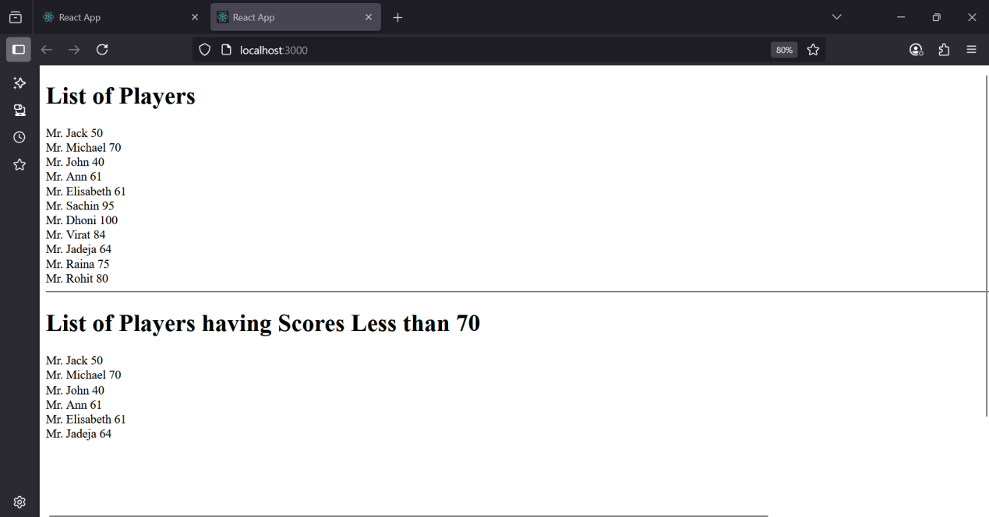

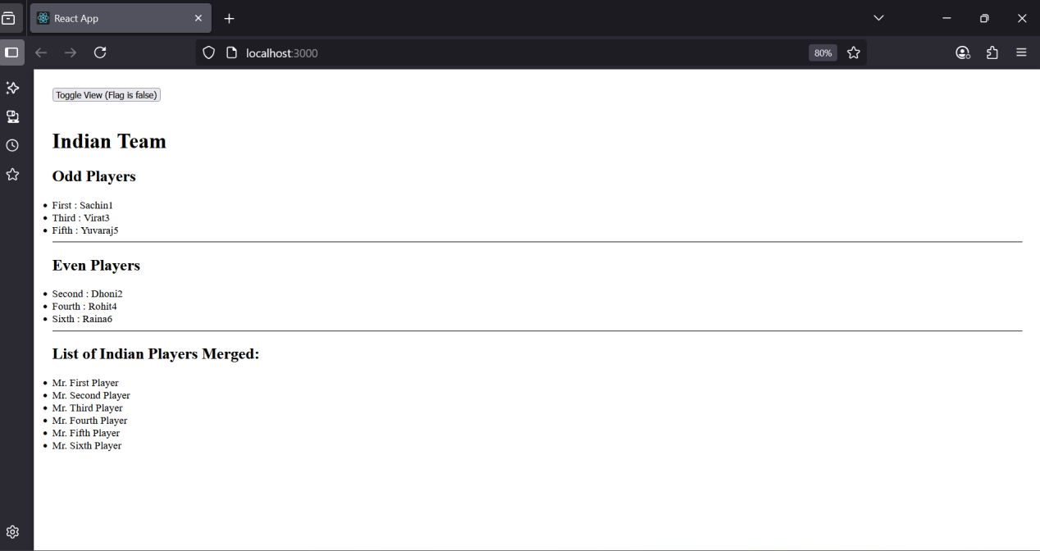

**10.ReactJS-Handson**

**App.js**

import React from 'react';

import './App.css';

import officeImage from './office.jpg';

function App() {

const officeList = [

{ Name: "DBS", Rent: 50000, Address: "Chennai" },

{ Name: "WeWork", Rent: 75000, Address: "Bangalore" },

{ Name: "SmartWorks", Rent: 45000, Address: "Pune" },

];

return (

<div className="App">

<h1><strong>Office Space</strong> , at Affordable Range</h1>

{officeList.map((item, index) => {

let rentColor = item.Rent <= 60000 ? 'textRed' : 'textGreen';

return (

<div key={index} className="office-card">

<img src={officeImage} alt="Office Space" width="25%" height="25%" />

<h1>Name: {item.Name}</h1>

<h3 className={rentColor}>Rent: Rs. {item.Rent}</h3>

<h3>Address: {item.Address}</h3>

</div>

);

})}

</div>

);

}

export default App;

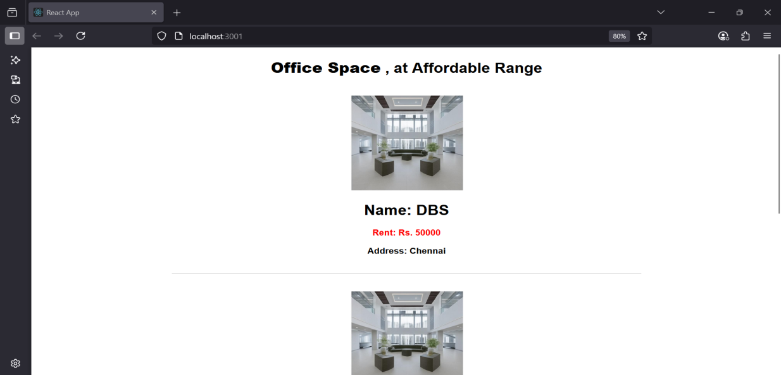

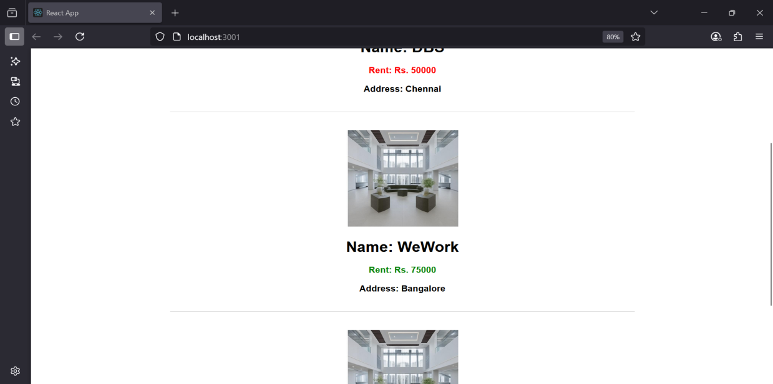

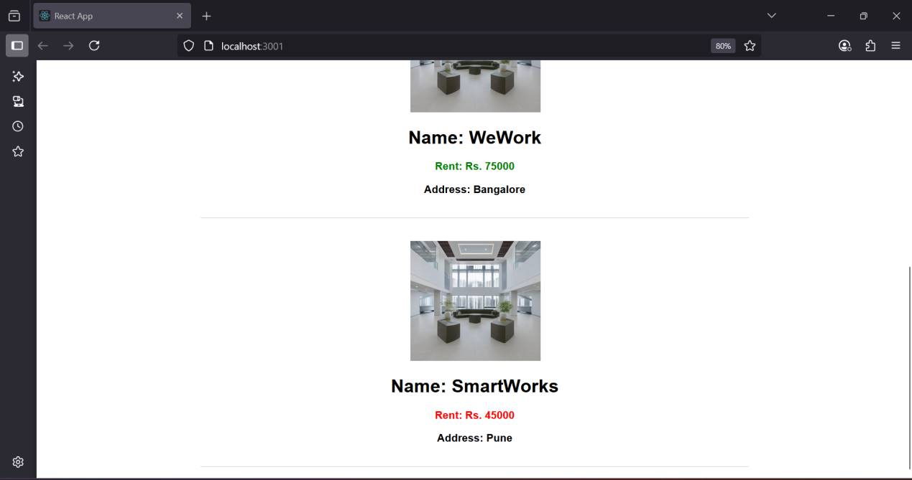

**11.ReactJS-Handson**

**App.js**

import React, { useState } from 'react';

import CurrencyConverter from './CurrencyConverter';

function App() {

const [count, setCount] = useState(5);

const increment = () => {

setCount(prev => prev + 1);

sayHello();

};

const decrement = () => {

setCount(prev => prev - 1);

};

const sayHello = () => {

alert("Hello! Member1");

};

const sayWelcome = (message) => {

alert(message);

};

const handleClick = () => {

alert("I was clicked");

};

return (

<div style={{ margin: '20px' }}>

<h2>{count}</h2>

<button onClick={increment}>Increment</button> <br />

<button onClick={decrement}>Decrement</button> <br />

<button onClick={() => sayWelcome("welcome")}>Say welcome</button> <br />

<button onClick={handleClick}>Click on me</button> <br /><br />

<CurrencyConverter />

</div>

);

}

export default App;

**CurrencyConverter.js**

import React, { useState } from 'react';

const CurrencyConverter = () => {

const [amount, setAmount] = useState('');

const [currency, setCurrency] = useState('');

const handleSubmit = (e) => {

e.preventDefault();

const euroRate = 80;

const converted = amount * euroRate;

alert(Converting to ${currency} Amount is ${converted});

};

return (

<div>

<h1 style={{ color: 'green' }}>Currency Convertor!!!</h1>

<form onSubmit={handleSubmit}>

<label>Amount: </label>

<input

type="number"

value={amount}

onChange={(e) => setAmount(e.target.value)}

/><br /><br />

<label>Currency: </label>

<textarea

value={currency}

onChange={(e) => setCurrency(e.target.value)}

/><br /><br />

<button type="submit">Submit</button>

</form>

</div>

);

};

export default CurrencyConverter;

**App.css**

.App {

text-align: center;

}

.App-logo {

height: 40vmin;

pointer-events: none;

}

@media (prefers-reduced-motion: no-preference) {

.App-logo {

animation: App-logo-spin infinite 20s linear;

}

}

.App-header {

background-color: #282c34;

min-height: 100vh;

display: flex;

flex-direction: column;

align-items: center;

justify-content: center;

font-size: calc(10px + 2vmin);

color: white;

}

.App-link {

color: #61dafb;

}

@keyframes App-logo-spin {

from {

transform: rotate(0deg);

}

to {

transform: rotate(360deg);

}

}

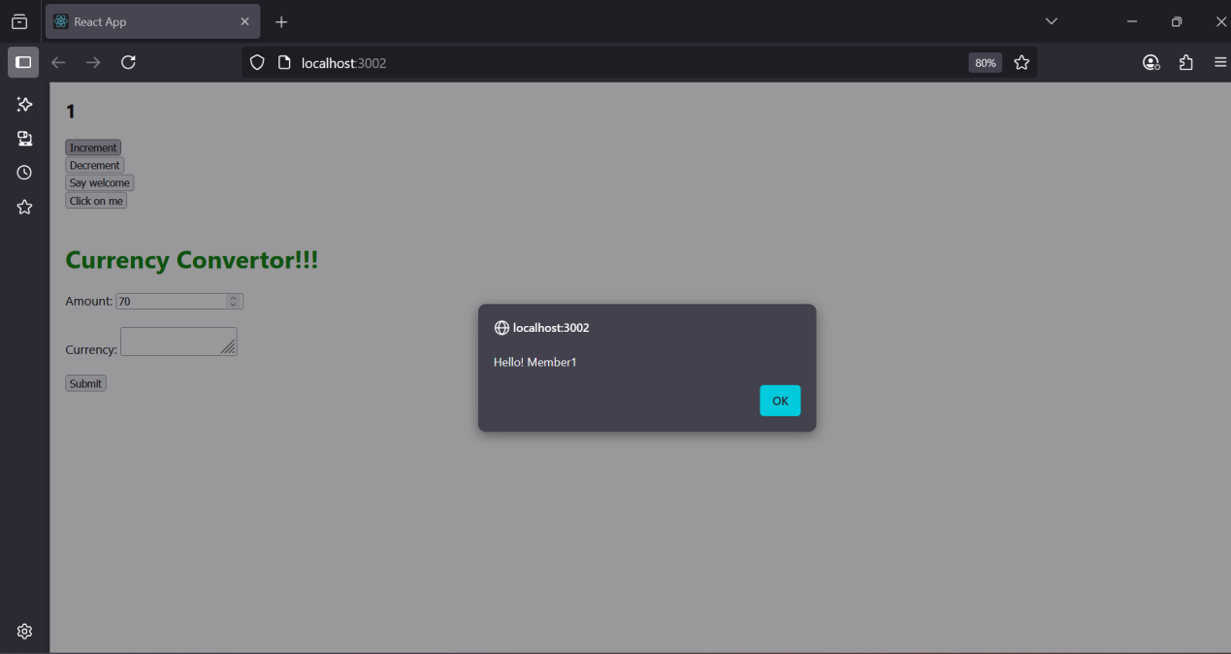

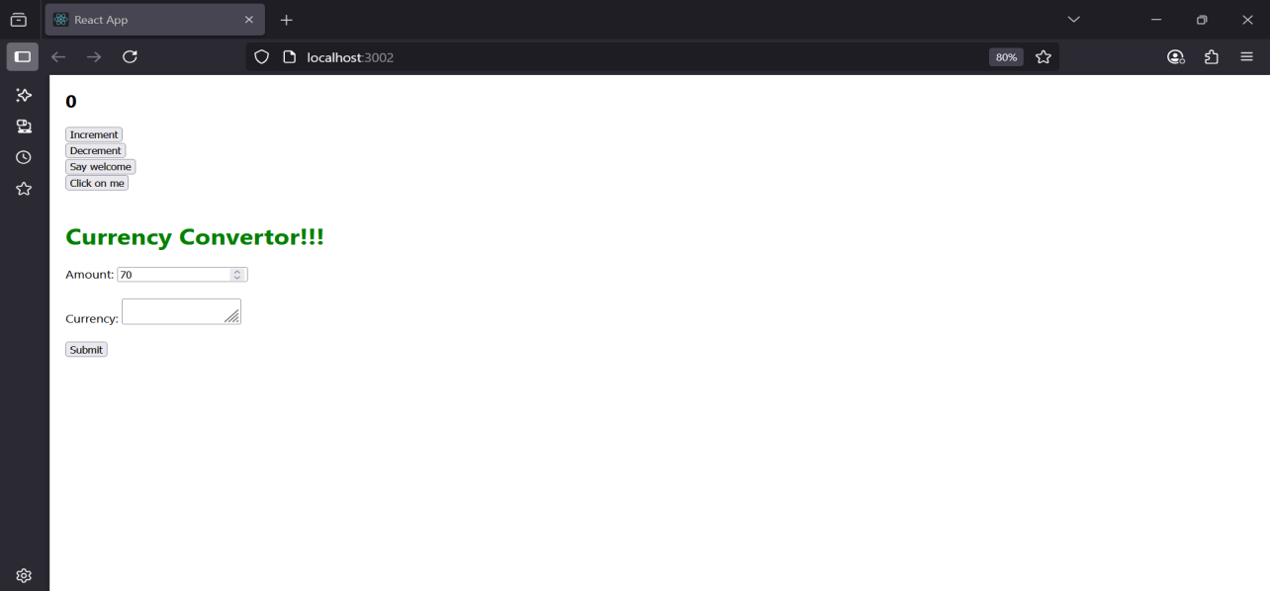

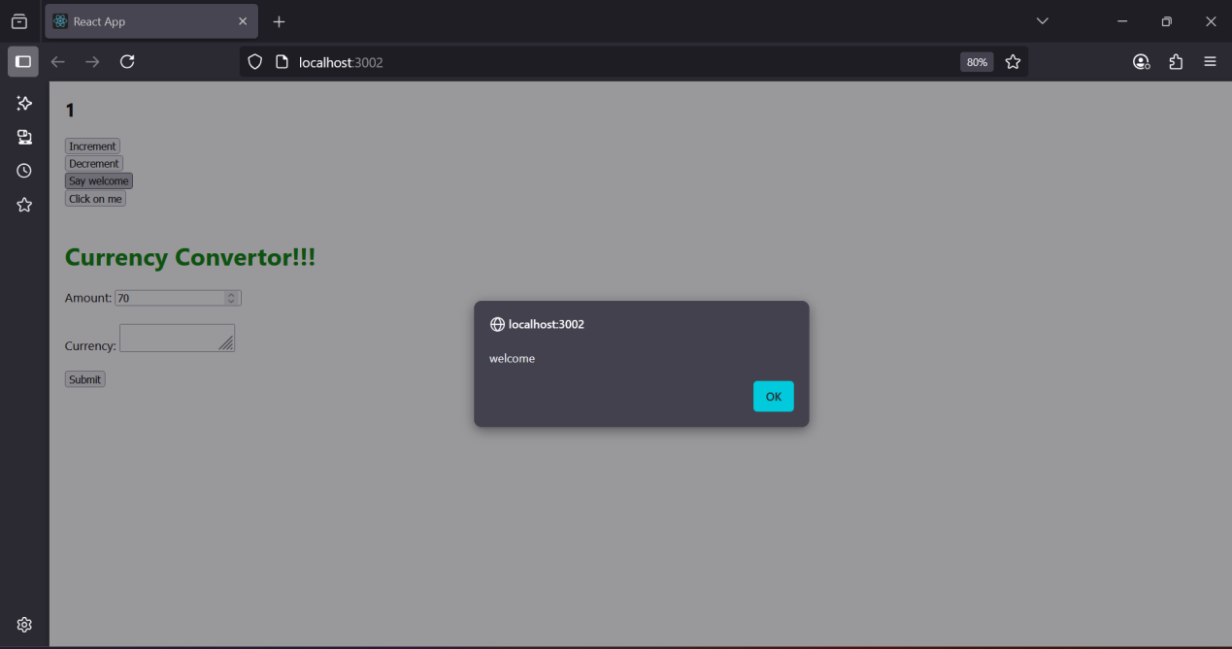

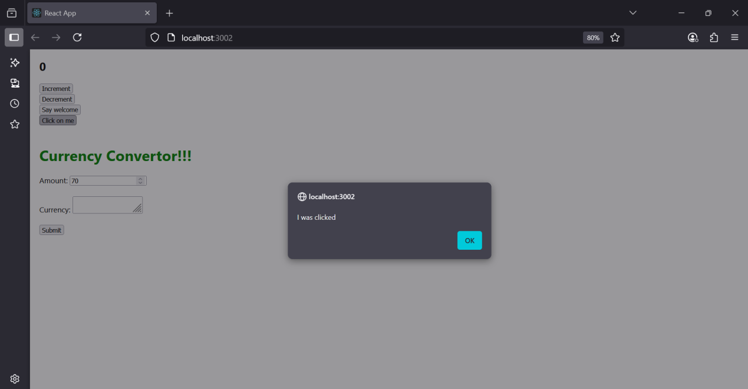

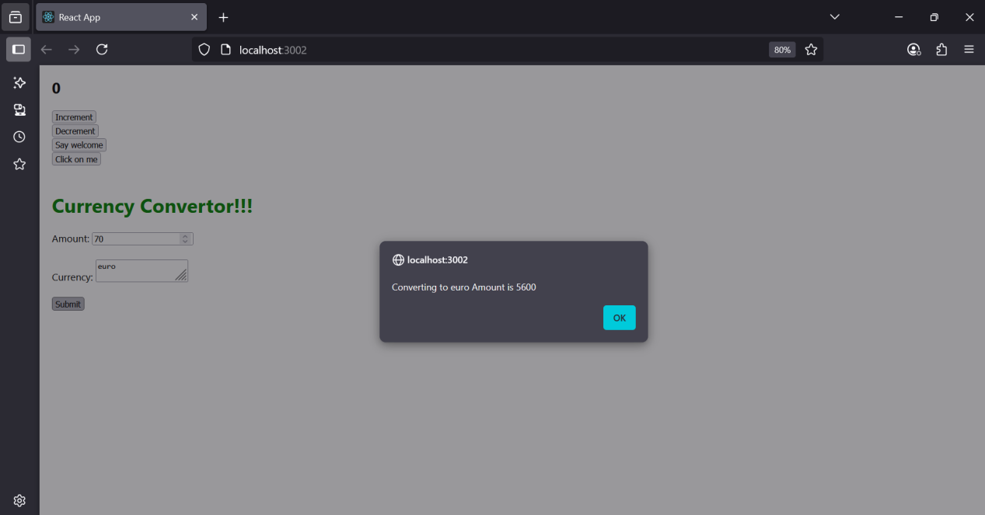

1. **ReactJS-Handson**

**App.js**

import React, { useState } from 'react';

import Greeting from './components/Greeting';

import LoginButton from './components/LoginButton';

import LogoutButton from './components/LogoutButton';

import FlightDetails from './components/FlightDetails';

import BookTicket from './components/BookTicket';

function App() {

const [isLoggedIn, setIsLoggedIn] = useState(false);

const handleLoginClick = () => setIsLoggedIn(true);

const handleLogoutClick = () => setIsLoggedIn(false);

return (

<div style={{ textAlign: 'center', marginTop: '50px' }}>

<Greeting isLoggedIn={isLoggedIn} />

{isLoggedIn ? (

<>

<LogoutButton onClick={handleLogoutClick} />

<BookTicket />

</>

) : (

<>

<LoginButton onClick={handleLoginClick} />

<FlightDetails />

</>

)}

</div>

);

}

export default App;

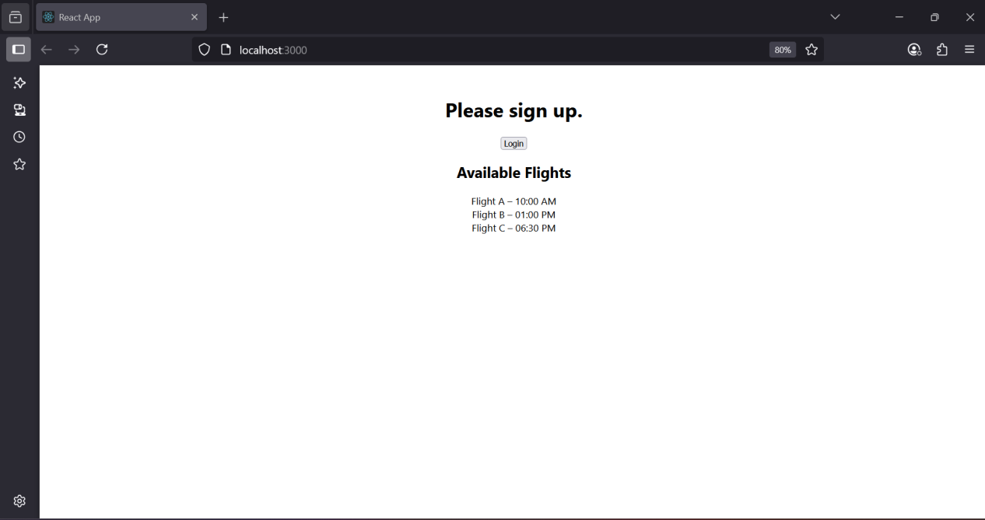

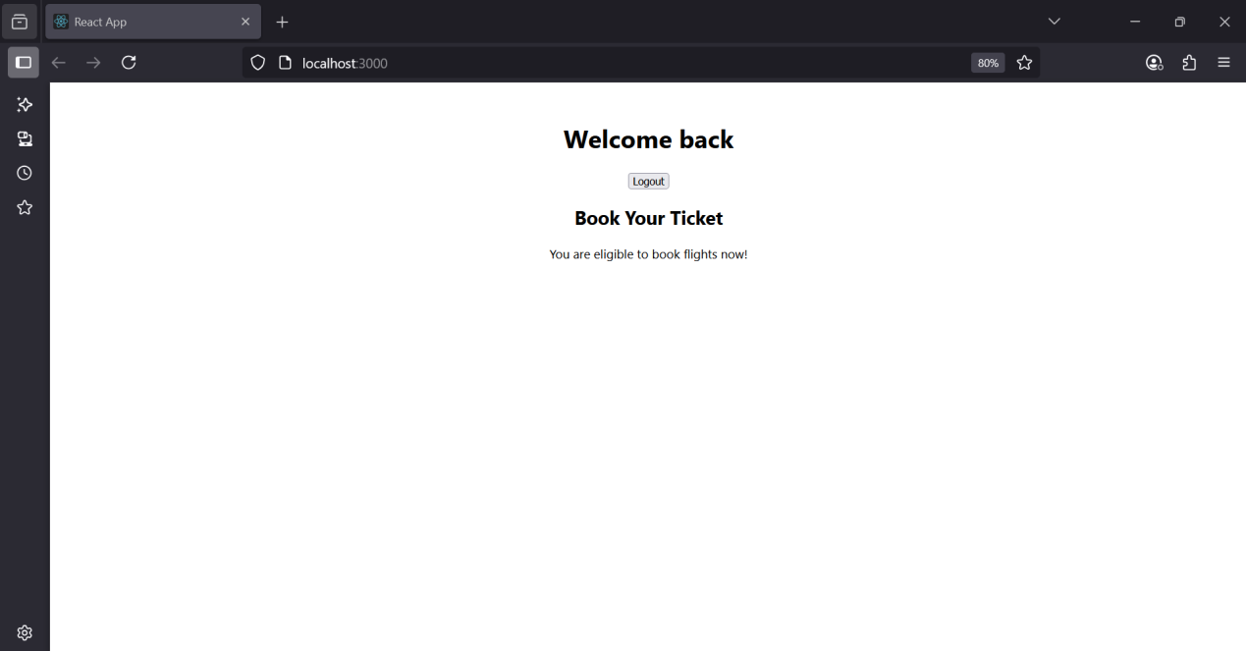

1. **ReactJS-Handson**

**App.js**

import React from 'react';

import './App.css';

import BookDetails from './components/BookDetails';

import BlogDetails from './components/BlogDetails';

import CourseDetails from './components/CourseDetails';

import { books } from './data/books';

function App() {

const showBlog = true;

const showCourse = true;

return (

<div className="container">

<div className="col mystyle1">

<h1>Course Details</h1>

<CourseDetails show={showCourse} />

</div>

<div className="col st2">

<h1>Book Details</h1>

<BookDetails books={books} />

</div>

<div className="col v1">

<h1>Blog Details</h1>

{showBlog && <BlogDetails show={showBlog} />}

</div>

</div>

);

}

**App.css**

export default App;

.container {

display: flex;

justify-content: space-around;

margin-top: 50px;

font-family: Arial, sans-serif;

}

.col {

width: 30%;

}

.mystyle1 {

font-weight: bold;

}

.v1 {

border-left: 3px solid green;

padding-left: 10px;

font-weight: bold;

}

.st2 {

border-left: 3px solid green;

padding-left: 10px;

font-weight: bold;

}

**BookDetails.js**

import React from 'react';

const BookDetails = (props) => {

return (

<ul>

{props.books.map((book) => (

<div key={book.id}>

<h3>{book.bname}</h3>

<h4>{book.price}</h4>

</div>

))}

</ul>

);

};

export default BookDetails;

**CourseDetails.js**

import React from 'react';

const CourseDetails = ({ show }) => {

return show ? (

<>

<h2>Angular</h2>

<h4>4/5/2021</h4>

<h2>React</h2>

<h4>6/3/20201</h4>

</>

) : null;

};

export default CourseDetails;

**BlogDetails.js**

import React from 'react';

const BlogDetails = ({ show }) => {

if (!show) return null;

return (

<div>

<h2>React Learning</h2>

<h4><strong>Stephen Biz</strong></h4>

<p>Welcome to learning React!</p>

<h2>Installation</h2>

<h4><strong>Schwezdiener</strong></h4>

<p>You can install React from npm.</p>

</div>

);

};

export default BlogDetails;

**Book.js**

export const books = [

{ id: 101, bname: 'Master React', price: 670 },

{ id: 102, bname: 'Deep Dive into Angular 11', price: 800 },

{ id: 103, bname: 'Mongo Essentials', price: 450 },

];

